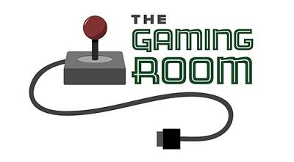

<Name-of-Software-Application>

CS 230 Project Software Design Template
Version 1.0

Table of Contents

CS 230 Project Software Design Template 1
Table of Contents 2
Document Revision History 2
Executive Summary 3
Requirements 3
Design Constraints 3
System Architecture View 3
Domain Model 3
Evaluation 4
Recommendations 5

Document Revision History

Version | Date | Author | Comments
1.0  2.0  3.0  4.0 | 05/22/2025  5/27/2025  6/8/2025  6/25/25 | Jason Guiste  Jason Guiste  Jason Guiste  Jason Guiste | Created the executive summary as well as outlined the requirements and design constraints.  Corrected grammatical errors. Expanded upon executive summery, added additional design constraints, added description of Domain model  Completed Evaluation table  Added recommendations.

Instructions
Fill in all bracketed information on page one (the cover page), in the Document Revision History table, and below each header. Under each header, remove the bracketed prompt and write your own paragraph response covering the indicated information.

Executive Summary

<Write a summary to introduce the software design problem and present a solution. Be sure to provide the client with any critical information they must know in order to proceed with the process you are proposing.>

Requirements

< Please note: While this section is not being assessed, it will support your outline of the design constraints below. In your summary, identify each of the client’s business and technical requirements in a clear and concise manner.>

Design Constraints

<Identify the design constraints for developing the game application in a web-based distributed environment and explain the implications of the design constraints on application development.>

System Architecture View

Please note: There is nothing required here for these projects, but this section serves as a reminder that describing the system and subsystem architecture present in the application, including physical components or tiers, may be required for other projects. A logical topology of the communication and storage aspects is also necessary to understand the overall architecture and should be provided.

Domain Model

<Describe the UML class diagram provided below. Explain how the classes relate to each other. Identify any object-oriented programming principles that are demonstrated in the diagram and how they are used to fulfill the software requirements efficiently.>

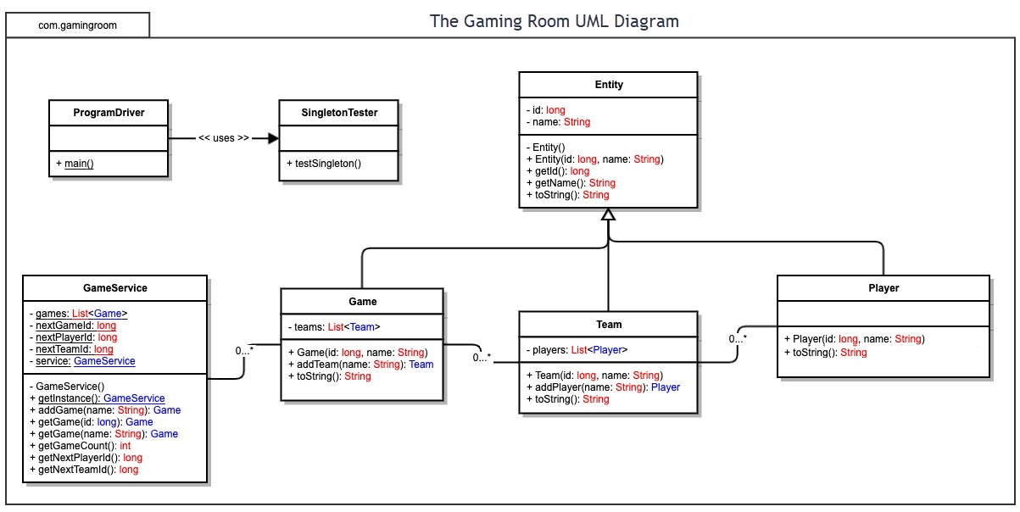

Evaluation

Using your experience to evaluate the characteristics, advantages, and weaknesses of each operating platform (Linux, Mac, and Windows) as well as mobile devices, consider the requirements outlined below and articulate your findings for each. As you complete the table, keep in mind your client’s requirements and look at the situation holistically, as it all has to work together.

In each cell, remove the bracketed prompt and write your own paragraph response covering the indicated information.

Development Requirements | Mac | Linux | Windows | Mobile Devices
Server Side | Flexible commands to configure the server, access, or make changes.  Characteristics: Popular in web hosting  Advantages It is upgradeable, has various options for different web hosting requirements  Disadvantages Less preferred for web hosting service | The same as for mac plus more cost-friendly.  Characteristics Secured, most preferred.  Advantages Security flaws are caught before they become an issue, it is the most preferred choice for web hosting services  Disadvantages It is more difficult to find applications to support the web hosting required needs. | More software available compared to other Operating Systems.  Characteristics It is dominant to the other platforms. Close platform  Advantages High resource requirements, less loading time, high comfortability  Disadvantages easy virus susceptibility, poor tech support | It is better if the server is immobile and can be tracked in a single place. Specifications are better in other devices.  Characteristics More popular, high portability.  Advantages Have a wider reach, better compatibility, cost-effective  Disadvantages Highly selective to various smart mobile devices Poor security
Client Side | Moderate expertise and time required. Cost similar to Windows. | Maximum expertise and time required. Minimum cost. | Minimum expertise and time required. Cost similar to Mac OS. | Provides flexibility to clients or even developers to see updates at any place. Slightly more difficult to implement than other devices
Development Tools | When running languages on MacOS we can run swift, the more popular option. While mixing in nice tools like notepad++. Though Macs can run all languages. Languages consist of but not limited to HTML/CSS/JavaScript while supporting libraries to support the frontend and general-purpose languages. These can be Java, Python, PHP, and Ruby. | Linux can work with Visual Studio, Eclipse, along with notepad++ for a nice and easy-to-use tool. Along with many more languages and tools. Languages consist of but not limited to HTML/CSS/JavaScript while supporting libraries to support the frontend and general-purpose languages. These can be Java, Python, PHP, and Ruby. | Easier to use than Linux but can run the same as it. So Visual Studio, Eclipse to name a few of the many languages. And with multiple tools notepad++ is a simple to use the tool. Languages consist of but not limited to HTML/CSS/JavaScript while supporting libraries to support the frontend and general-purpose languages. These can be Java, Python, PHP, and Ruby. | You can create countless apps using android and swift. Both languages and software can be run on all three machines. Languages consist of but not limited to HTML/CSS/JavaScript while supporting libraries to support the frontend and general-purpose languages. These can be Java, Python, PHP, and Ruby.

Recommendations

Analyze the characteristics of and techniques specific to various systems architectures and make a recommendation to The Gaming Room. Specifically, address the following:

- Operating Platform: Given the client's requirements, I suggest using Linux as the server's operating system. Linux is a popular choice for server environments thanks to its reliability, strong security features, and high performance. It offers robust support for web-based applications and can be extensively customized to meet specific development needs. Furthermore, as an open-source platform, Linux benefits from a large, active community that continually enhances and maintains the system. Since Draw It or Lose It is a web-based application, Linux would be a fitting and effective platform for hosting the game.

- Operating Systems Architectures: For the suggested distributed system, adopting a multi-tier architecture is advisable. This architectural approach divides the application into three distinct layers: presentation, application, and data. By separating these tiers, the system can achieve better scalability and enhanced fault tolerance. The presentation layer manages the user interface, the application layer processes the core business logic, and the data layer handles data storage and retrieval.

- Storage Management: Since the game requires rendering images from an extensive library of stock drawings, a high-speed storage solution is essential to maintain smooth gameplay. I recommend utilizing a solid-state drive (SSD) for the server’s storage. Compared to traditional hard drives, SSDs offer significantly faster read and write speeds, which would enhance image loading times and overall performance.

- Memory Management: The suggested operating system, Linux, offers robust memory management capabilities. It employs a paging mechanism that efficiently utilizes physical memory by moving inactive data to disk storage when necessary. This approach helps optimize memory usage, which would enhance the performance of the Draw It or Lose It application.

- Distributed Systems and Networks: To facilitate communication across different platforms, implementing a RESTful API is recommended. RESTful APIs are commonly used in web applications and allow data exchange over the internet via HTTP protocols. Linux, the proposed operating system, offers strong support for RESTful APIs and simplifies their deployment and integration.
- Security: Security is a vital component of any web-based application, and Draw It or Lose It is no exception. The recommended operating system, Linux, offers strong security capabilities, including built-in firewalls and robust access control mechanisms. It is also widely regarded as more resilient to security threats compared to many other operating systems. To safeguard user data across all platforms, implementing SSL/TLS encryption for all communications is advisable. This would ensure that data exchanged between the server and clients remains protected from unauthorized access and interception.

